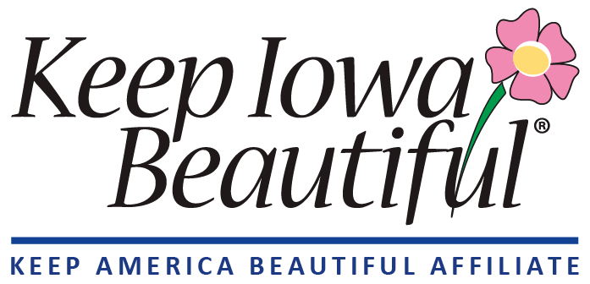

For Immediate Release: Press Contact:
October 23, 2025 Andy Frantz, Executive Director
Ph: 515-770-1844
afrantz@keepiowabeautiful.org

Celebrate Photographer Appreciation Month with Keep Iowa Beautiful’s 16th Annual Photography Contest
In recognition of Photographer Appreciation Month, Keep Iowa Beautiful is inviting photographers of all skill levels to enter the 16th Annual Keep Iowa Beautiful Photography Contest. The contest highlights the people and places that make Iowa unique—its landscapes, wildlife, and communities.
“The Keep Iowa Beautiful Photography Contest is an opportunity to celebrate Iowa’s photographers and the many ways they capture our state’s beauty,” said Andy Frantz, Executive Director of Keep Iowa Beautiful. “Their work reminds us of the pride Iowans have in their communities and the places they call home.”
Entries are open through Friday, December 12, 2025, and may be submitted in six categories:
- Iowa Landscape: Capture Iowa’s beauty through depictions of Iowa’s landscape, including but not limited to: farm fields, rolling hills, and wooded forests.
- Iowa Water: Feature Iowa’s beautiful water systems with depictions of Iowa rivers, streams, ponds and lakes.
- Iowa Cities: Iowa’s urban centers are hubs of history, culture, and beauty. This category features depictions of Iowa’s cities, street scenes, and urban landmarks.
- Iowans In Action: This category aims to capture the spirit of Iowa through depictions of the people that live, work, and play in Iowa. All means of action that can be captured: biking, running, fishing, hunting and hiking are but a few.
- Iowa Wildlife: Iowa is home to a variety of beautiful critters. This category aims to showcase Iowa’s beauty through depictions of Iowa’s wildlife animals: mammals, fish, birds, bugs and more!
- Hometown Pride: 100+ Iowa towns have participated in our “Hometown Pride” program. This category features depictions of Hometown Pride towns and/or photos of activities by Hometown Pride committees. Please review the list of Hometown Pride towns to see if your photo qualifies.
Prizes will be awarded in each of the six contest categories: $100 for first place, $75 for second place, and $50 for third place.
In February 2026, first-place photos will be shared on Keep Iowa Beautiful’s social media pages, where the public can vote for their favorite. The photo with the most votes will earn an additional $100 prize and the title of Public Favorite Photo.
At that same time, a panel of judges will select the winners of the Robert D. Ray Best of Show Awards, honoring the contest’s top overall photographs. Best of Show prizes include $500 for first place, $250 for second place, and $100 for third place.
New this year: a special Youth Award will be presented to one photographer in grades K–12 (age 18 or under). The youth winner will receive $100, and their photo will also be eligible for all other contest categories.
A $5 fee is required for each photo entered. Contest rules and entry guidelines can be found on Keep Iowa Beautiful’s website: https://keepiowabeautiful.org/photography-contest/.

Photo Reproduction Rights
Photographers retain all copyrights associated with their photograph(s). Entry in the contest constitutes agreement to allow winning photographs to be published and used by KIB on our social media, website, program materials and emails. Examples of typical use include: posting the winning photographs on our website and social media, including photos in our monthly e-newsletter, publishing winners in our annual report, and promoting the photo contest on social media. Photographers will be given credit when their photo is used. KIB will never sell your photos to any outside source. Inquiries by third parties regarding use of the photos will be referred directly to the photographer.

About Keep Iowa Beautiful
Founded in 2000 by Governor Robert D. Ray and Donald F. Lamberti, Keep Iowa Beautiful is a statewide non-profit empowering Iowans to bring cultural and economic vitality into their communities through improvement and enhancement programs. An affiliate of the Keep America Beautiful program, Keep Iowa Beautiful focuses on programming built on the pride we feel for our towns and the people in them. To learn more about our programs or to donate, please visit our website at https://keepiowabeautiful.org/.

