Welcome to Pick-Up Iowa 2024! Elevate your event promotion with these social media graphics designed by Keep Iowa Beautiful. We've curated a collection of resources, including customizable templates, to enhance your Pick-Up Iowa initiatives. Simply sign up for a free Canva account, explore our graphics, and tailor them to your event's unique need-to-know information. Let's make Iowa even more beautiful together!
Access the templates here:
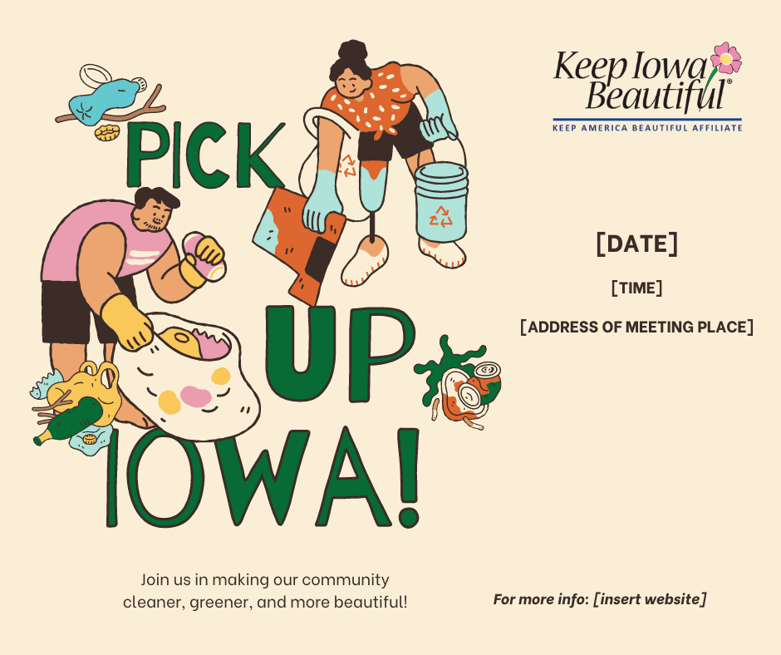
Download and edit here: https://www.canva.com/design/DAF-9dEhcKI/JJP2VDwXFed4JDEeEDUqLQ/edit?utm_content=DAF-9dEhcKI&utm_campaign=designshare&utm_medium=link2&utm_source=sharebutton
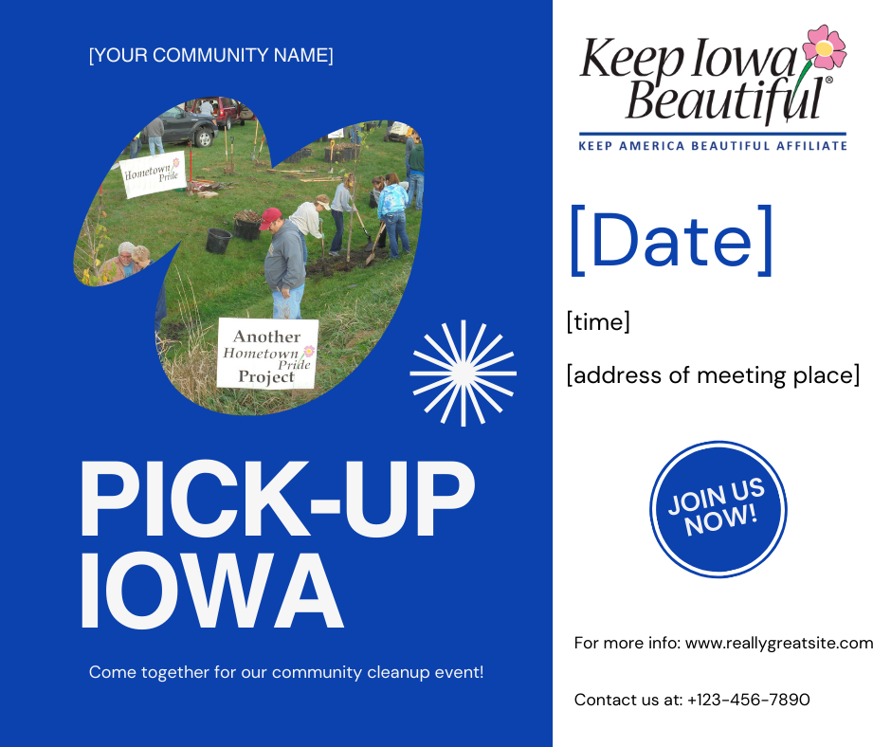
Download and edit here: https://www.canva.com/design/DAF_N3BTdJo/RecGmgxTMrHBGE304Mn8eQ/edit?utm_content=DAF_N3BTdJo&utm_campaign=designshare&utm_medium=link2&utm_source=sharebutton
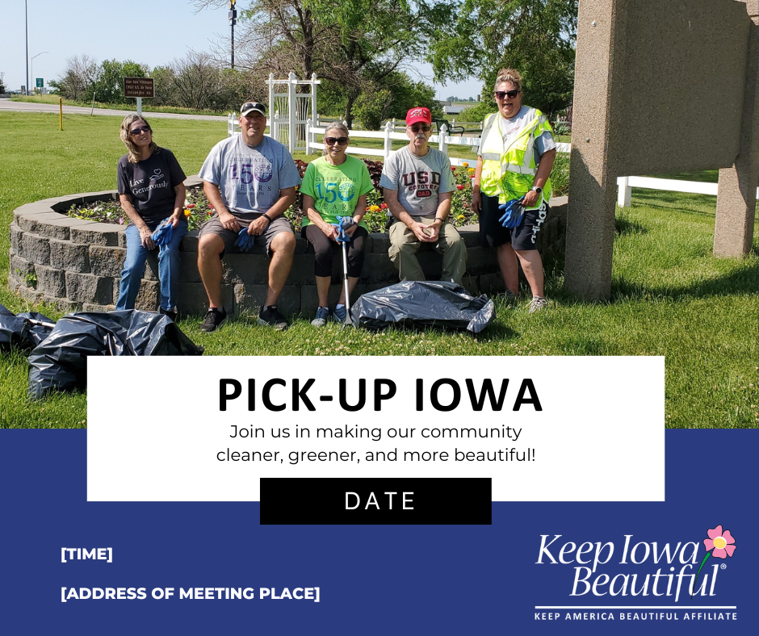
Download and edit here: https://www.canva.com/design/DAF_N5k0qy4/neukSTIti7MznAatboLSHg/edit?utm_content=DAF_N5k0qy4&utm_campaign=designshare&utm_medium=link2&utm_source=sharebutton
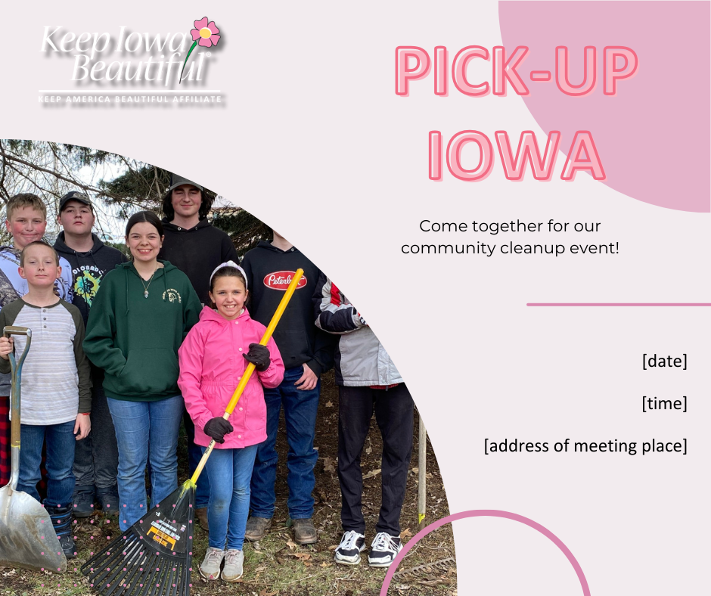
Download and edit here: https://www.canva.com/design/DAF_OOLjzzQ/0bgZ5t4z2LbTv37sJQZcFw/edit?utm_content=DAF_OOLjzzQ&utm_campaign=designshare&utm_medium=link2&utm_source=sharebutton

